Secuura × VIT POC
Architecture Reference Document
Secure Document Verification System
This document describes the full architecture control model for the Secuura × VIT Proof of Concept. It is intended for architecture review by Secuura AI and technical stakeholders. Prototype delivery scope, team responsibilities, and implementation details are covered in the accompanying Prototype Delivery Plan.

1. Executive Summary
Secuura × VIT POC is a proof-of-concept architecture for recruitment document verification built with enterprise security and privacy controls from the outset. It applies zero-trust principles by authorizing access per user, per session, and per resource rather than relying on network location, consistent with NIST SP 800-207.
The system verifies text-based PDFs first, supports generic document intake, and limits high-assurance outcomes to documents that can be validated through approved trust sources. The architecture uses a deferred verification workflow: upload stores the document only in transient encrypted storage, and processing begins only when an authorized reviewer opens the verification session. This reduces unnecessary exposure of sensitive content and narrows the active data window.
The retention model is content-minimised retention, not zero-retention. Raw documents, extracted claims, OCR output, grounded coordinates, and connector payloads are deleted after the session. A minimal audit record persists for accountability and evidentiary purposes. That record remains regulated metadata where applicable and is therefore governed by the same privacy and access-control framework as other personal data.
The design is intentionally bounded for a POC. It demonstrates secure upload, deterministic extraction, trusted validation, controlled auditability, and enforceable cleanup without claiming full production breadth.

2. Prototype vs Production Boundary

Genuinely Implemented in the Prototype
- Upload and session flow
- One-time token logic
- PDF extraction
- Local OCR fallback
- Spatial grounding
- Connector broker interface
- Trust engine with Green/Amber/Red logic
- Audit commitment and signed receipt
- Content deletion after session close
- Log redaction
- Input validation
- PDF safety controls

Production Target Architecture — Not Implemented in Prototype
- Kubernetes orchestration
- KMS-backed encryption
- Enterprise SSO
- mTLS between services
- HSM-backed recovery vault
- Multi-AZ PostgreSQL
- Live blockchain anchoring

Mocked or Simulated for Demo Purposes
- VIT Registry Connector using JSON fixture file
- VC Verification Connector using hardcoded credential
- Cardano anchoring replaced by hash display
- Redis replaced by PostgreSQL state

3. Business Problem and Objectives
Recruitment and onboarding processes rely on PDFs such as transcripts, certificates, and identity documents. Manual review is slow and inconsistent. Simple extraction alone is insufficient because it may misread content, cannot prove authenticity, and often expands data-retention risk.
The architecture addresses four objectives:
- Reduce manual verification effort for recruitment workflows.
- Minimise retained personal data by holding content only for the active session.
- Ground extracted claims back to the PDF so the system can show where a value came from.
- Validate claims against trusted sources before issuing a high-assurance decision.
The privacy model is shaped by data-minimisation, storage-limitation, integrity/confidentiality, and accountability principles under GDPR. For transcript workflows operated for educational institutions, FERPA may also apply because education records and their disclosure are regulated.

4. Recruitment Verification Use Case
An authorized recruiter receives a candidate-submitted PDF. The recruiter creates a verification session and uploads the file through a one-time upload token. The system stores the file only in encrypted transient storage. No extraction or verification occurs at upload time.
When the recruiter opens the verification session, the system launches a session-scoped worker. The worker parses the PDF, extracts candidate fields, grounds them to visible document locations, and invokes the appropriate trust source.
The decision model is deterministic:
Green: trusted source verifies the required claims and no critical mismatch exists.
Amber: claims are grounded in the PDF, but high-assurance verification is not available for that document class under policy.
Red: trusted verification fails, critical claims mismatch, a required high-assurance source is unavailable after retries, or the document cannot be processed safely.
The recruiter sees the outcome, reason codes, and temporary evidence. After the session ends, content-bearing artifacts are deleted and only a minimal audit proof remains.

5. Scope Definition (POC Boundaries)

In scope
The POC includes:
- secure session creation and one-time upload tokens
- text-PDF processing first
- local OCR fallback for supported low-text PDFs
- canonical field extraction
- spatial grounding
- VIT registry verification
- Verifiable Credential linkage for selected samples
- deterministic trust engine
- content-minimised audit proofing
- cloud deployment with enterprise security controls
- disaster recovery for persistent audit data
- explicit cleanup on success, failure, timeout, or worker crash

Out of scope
The POC does not include:
- broad production-scale issuer coverage
- persistent document archives
- full mobile capture flows
- multi-tenant productization
- all identity-document classes
- production SLA commitments beyond the POC targets defined in Section 22
- blockchain as a required dependency for core verification

POC support boundaries
The baseline POC supports:
Input format: PDF only
Document types: recruitment-relevant academic and credential documents; selected identity documents only where policy approved
High-assurance connectors: VIT registry and selected VC path
OCR model: local OCR only in baseline; external OCR disabled by default

6. High-Level Solution Overview
The solution has four planes:
Identity plane: authentication, MFA (simulated in prototype), RBAC, and service identity
Processing plane: upload, transient storage, worker execution, extraction, and trust evaluation
Cryptographic plane: key management, commitment generation, signing, and encryption
Audit plane: minimal receipt storage, integrity protection, optional external anchoring

The architecture is designed so that content is short-lived, while audit evidence is minimal, pseudonymised where possible, and separately protected. The system does not claim anonymity; it claims minimisation, bounded processing, and strict separation between operational content and retained evidence.

7. System Architecture
The system consists of:
- Identity-Aware Access Gateway
- Upload Session Service
- Transient Encrypted Object Store
- Durable Workflow Store
- Verification Orchestrator
- Session-Scoped Verification Workers
- Extraction and Grounding Services
- Connector Broker
- Trusted Connectors
- Trust Engine
- Secure Reviewer UI
- Audit Commitment Service
- Append-Only Audit Store
- Cleanup Controller
- Recovery Table for sealed nonces (second encrypted PostgreSQL table with a separate key)
- Optional Cardano Anchor Worker
The control boundary is the worker. Only the worker can handle raw document content, and each worker is bound to exactly one verification session.

8. Component Architecture

8.1 Identity-Aware Access Gateway
The gateway terminates TLS, enforces JWT-based login with username and password, session binding, and API authorization. Zero-trust guidance from NIST emphasizes protecting users, assets, and resources directly rather than relying on a wide perimeter.

8.2 Upload Session Service
This service creates a session, issues a one-time upload token, and records non-content state. It never stores document content itself.

8.3 Transient Encrypted Object Store
This holds uploaded PDFs before processing. Controls:
- Python cryptography library using Fernet with the key stored in an environment variable
- no versioning
- no backup
- object-level TTL
- no replication to analytics or indexing
- immediate delete on session completion
- partial-upload cleanup

8.4 Durable Workflow Store
A durable relational store holds session state, leases, worker heartbeats, and cleanup status. This prevents orchestration state from depending on an in-memory cache alone.

8.5 Verification Orchestrator
The orchestrator issues a single worker lease using an atomic state transition in the workflow store. Duplicate starts are prevented by a unique active-lease constraint on session_id.

8.6 Session-Scoped Verification Worker
Each worker is created as a one-shot Docker Compose service on a single machine or small VM for one session only. It receives:
- a short-lived workload identity
- scoped permission to read only one object path
- permission to call only approved connectors
- permission to post a minimal receipt
- no persistent storage entitlement

8.7 Extraction Pipeline
The extraction pipeline handles PDF parsing, OCR fallback, canonical field mapping, and confidence scoring.

8.8 Spatial Grounding Service
This service links extracted values to page coordinates and line positions for live reviewer inspection.

8.9 Connector Broker
This provides a normalized contract for all connectors, including status, reason codes, matched claims, mismatched claims, and assurance class.

8.10 Trusted Connectors
The baseline POC uses:
- VIT Registry Connector
- VC Verification Connector

8.11 Trust Engine
Applies deterministic policy, including timeout rules by assurance class.

8.12 Audit Commitment Service
Generates the privacy-preserving document commitment, signs the receipt, and stores minimal metadata.

8.13 Append-Only Audit Store
Persistent store for signed receipts and integrity data. Insert-only at the application layer. Update allowed only for append-style supplemental fields such as purge completion and anchor status.

8.14 Cleanup Controller
A dedicated cleanup service owns explicit deletion, backstop TTL enforcement, and abandoned-session recovery.

9. End-to-End Data Lifecycle
The lifecycle is explicit.

Stage 1: Session creation
Persisted:
- session ID
- requester identity reference
- policy profile
- expiry time
No document exists yet.

Stage 2: Upload
The reviewer uploads through a one-time token. The PDF enters the transient encrypted object store.
Persisted temporarily:
- object path
- object checksum for transport integrity only
- upload status
- upload start and expiry timestamps

Stage 3: Deferred verification trigger
Verification begins only when the authorized reviewer opens the session. The orchestrator acquires the session lease and launches a worker.
Persisted:
- active worker lease
- lease holder ID
- heartbeat timestamp

Stage 4: Processing
The worker pulls the PDF into a Docker tmpfs mount on the local host where swap-disabled execution is supported. If the host cannot guarantee swap-disabled execution, the fallback is an encrypted ephemeral volume with session key destruction on worker termination. Extracted claims, OCR text, and grounded coordinates exist only inside the worker runtime.
Persisted:
- no raw content
- no extracted claims
- no grounded evidence

Stage 5: Trust decision
The worker receives normalized connector responses and the trust engine issues Green, Amber, or Red with reason codes.
Persisted:
- outcome class
- reason codes
- connector IDs used

- assurance profile

Stage 6: Audit commitment and receipt
The worker sends only the cryptographic inputs required to the Audit Commitment Service. The primary audit store receives the signed receipt and minimal metadata.

Stage 7: Cleanup
The worker terminates, the transient object is deleted, in-memory volumes are destroyed, and the cleanup controller records purge completion.
Persisted after cleanup:
- audit event ID
- pseudonymous reviewer reference
- outcome
- reason codes
- connector IDs
- issued timestamp
- receipt hash
- key version
- purge status
- optional anchor reference
No candidate document, extracted field, digest, or bounding-box evidence persists.

10. Verification Pipeline Sequence
- Reviewer authenticates through a JWT-based login with username and password.
- Gateway authorizes session creation.
- Upload Session Service issues one-time upload token.
- Reviewer uploads PDF.
- PDF lands in transient encrypted object store.
- Session waits in UPLOADED_PENDING_REVIEW.
- Reviewer opens the verification session.
- Gateway reauthorizes access.
- Orchestrator executes atomic PENDING → VERIFYING transition.
- Unique active lease is created for that session.
- Worker starts with scoped identity.
- Worker streams PDF into Docker tmpfs mount.
- Worker parses text; local OCR runs only if policy allows.
- Canonical fields are extracted.
- Fields are grounded to PDF positions.
- Connector Broker invokes approved trust source.
- Trust Engine evaluates connector results, confidence, and policy.
- Audit Commitment Service generates signed receipt.
- Reviewer sees result and live evidence.
- Cleanup Controller deletes transient object and verifies worker termination.
- Session moves to PURGED.
- Primary audit store retains minimal receipt metadata.

Failure paths
Upload token expired before first byte: token invalid, no object retained.
Upload token expired mid-upload: upload aborted; partial object deleted.
Duplicate worker start: second lease request rejected by unique constraint and returns no-op.
Worker heartbeat lost: session marked ABANDONED_VERIFYING; cleanup controller takes ownership.
Connector timeout: policy-based outcome, not automatic Amber.
Audit store unavailable: result not committed; cleanup still executes; session marked failed and retriable only by new session.

11. AI Extraction Pipeline
The baseline extraction model is deterministic-first and local-first.

Baseline pipeline
- PDF text extraction with PyMuPDF or pdfplumber
- local OCR fallback using Tesseract or PaddleOCR in private compute
- canonical field normalization with rule-based parsing
- optional model-assisted disambiguation inside the private environment

OCR policy
The baseline POC uses local OCR only. External OCR or external LLM-based extraction is disabled by default. If enabled in a later phase, provider access must pass through a privacy gate that enforces a DPA, approved region, approved retention setting, redaction policy, and approved endpoint list before any content can leave the trust boundary.

PDF safety controls
The POC enforces:
- PDF only
- maximum file size: 25 MB
- maximum page count: 200
- reject password-protected PDFs
- reject embedded JavaScript, launch actions, or attachments
- malware scan before processing
- parser sandboxing
- hard timeout on parsing and OCR
- malformed PDF rejection with reason code

12. Connector Framework
The connector broker exposes a uniform interface:
- connector_id
- assurance_class
- status
- reason_codes
- matched_claims
- mismatched_claims
- source_timestamp
- technical_state

Supported connector classes
1. Institutional Registry Connector
Deterministic lookup against a controlled VIT data source. In the prototype, the VIT Registry Connector is mocked using a JSON fixture file that returns structured match and no-match responses using the canonical connector schema.
2. Verifiable Credential Connector
Validates the cryptographic proof, status, issuer trust, expiry, and claim alignment. In the prototype, the VC Verification Connector is a mock that validates a hardcoded sample credential and returns structured verification responses.
Any connector can be attached to a real external API in production without modifying the broker interface or the trust engine.

Connector execution controls
- bounded retries
- per-connector timeout
- circuit breaker
- localhost or Docker network communication
- connector-specific assurance profile

13. Trust Engine Logic (Green / Amber / Red)
The trust engine is policy-driven and uses both document evidence and trust-source evidence.

Outcome rules
Green
- required claims are grounded
- no critical tamper signal
- at least one required connector returns VERIFIED
- no critical mismatch
Amber
- grounded document evidence exists
- no contradiction detected
- policy marks trusted verification as optional for that document class
- all required retries exhausted without a high-assurance source
Red
- mismatch, revoked or invalid credential, required connector unavailable after retry window, insufficient grounding on mandatory fields, unsafe document, or policy breach

Timeout policy
Connector timeout is not treated uniformly.
Document class | Assurance policy | Timeout result after retries
VIT transcript / degree used as primary qualification evidence | High assurance required | Red
VC-linked credential where VC verification is mandatory for the path | High assurance required | Red
Supplemental certificate with no mandated trust source | Verification optional | Amber
Generic supporting document with no approved connector class | Verification optional | Amber

Retry policy
- 2 immediate retries with jitter for transient network errors
- 1 deferred retry within session if remaining session TTL permits
- after retry exhaustion, trust engine applies the assurance policy above

14. Deferred Verification Workflow (Verify-on-View)
This document uses verify-on-view only as a label for the trigger condition. It is not presented as an industry-standard named pattern.
The workflow is:
- upload stores the document only in transient encrypted storage
- no parsing or verification occurs yet
- authorized reviewer opens the session
- gateway rechecks authorization
- orchestrator acquires single worker lease
- verification executes
- result is shown live
- cleanup begins as soon as the session ends or fails
This workflow reduces unnecessary processing and limits exposure of sensitive content to the period in which an authorized reviewer is actively assessing the file.

15. Privacy Architecture (Content-Minimised Retention)
The system uses a content-minimised retention architecture.
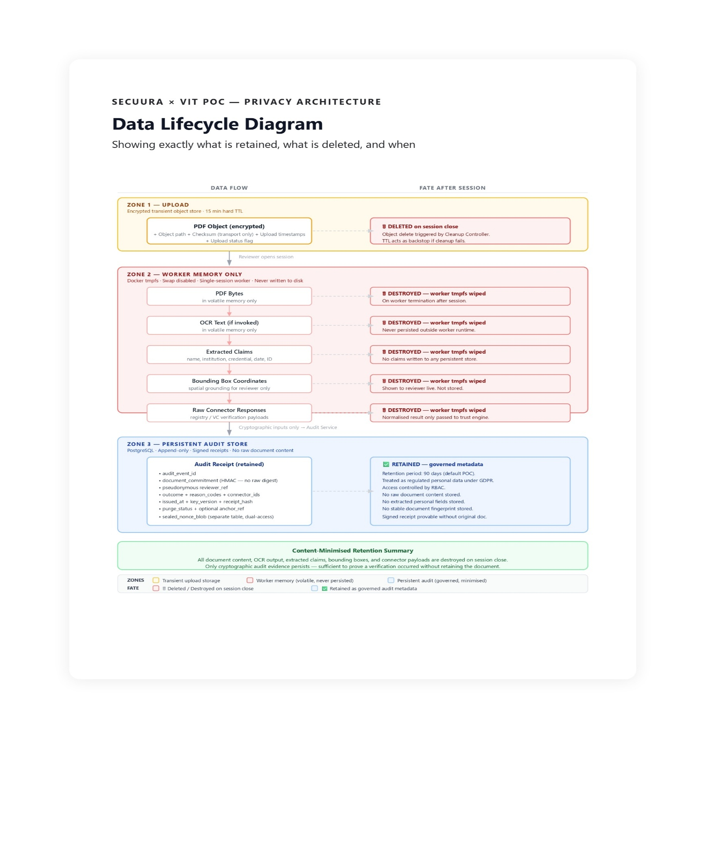
Figure 1. Data Lifecycle Diagram: retained vs deleted data across the verification session

Content deleted after the session
- uploaded PDF
- OCR output
- extracted claims
- grounded coordinates
- raw connector responses
- temporary thumbnails
- parser intermediates
- worker memory volumes
- transport integrity checksums
- per-session processing identifiers

Metadata retained
- audit event ID
- pseudonymous reviewer reference
- outcome class
- reason codes
- connector IDs
- issued timestamp
- key version
- receipt hash
- purge status
- optional blockchain reference

Privacy controls
GDPR establishes data-minimisation, storage-limitation, integrity/confidentiality, and accountability principles. The revised retention model treats persisted audit metadata as governed data rather than pretending it is outside privacy scope.

Pseudonymisation approach
The audit store does not keep raw reviewer usernames. It stores reviewer_ref = HMAC(K_identity_ref, jwt_subject_claim). The mapping back to the human user exists only in the JWT issuer record and the security admin process, not in the application database. In the prototype, the jwt_subject_claim is the username from the JWT-based login.

Retention periods
Default POC retention:
- audit receipts: 90 days
- security logs: 30 days hot, 90 days cold if required
- sealed nonce blobs: 90 days or shorter if dispute-reverification is not required
- transient objects: 15 minutes hard TTL

16. Audit Token and Proof Design
The audit proof is designed so that persistent records alone cannot be used to test candidate documents.

Design goals
- preserve evidentiary integrity
- avoid persistent stable document identifiers
- prevent routine cross-session correlation
- support controlled dispute verification
- keep blockchain anchoring content-free

Cryptographic design
Inside the worker, in volatile memory only:
- document_digest = SHA-256(normalized_pdf_bytes)
- verification_nonce = 256-bit CSPRNG
- scope_tag = tenant_id || assurance_profile || policy_version
- document_commitment = HMAC(K_commit_vN, scope_tag || document_digest || verification_nonce)

Storage model
Primary audit store
- audit_event_id
- document_commitment
- reviewer_ref
- outcome
- reason_codes
- connector_ids
- issued_at
- key_version
- receipt_hash
- purge_status
- optional anchor_ref
Recovery vault
- sealed_nonce_blob = Encrypt(K_recovery, verification_nonce || audit_event_id || key_version)
- no raw digest
- no document content
- no candidate identifiers
The nonce is not stored in the primary audit database. In the prototype, it is stored only as a sealed blob in a second encrypted PostgreSQL table with a separate key and logical dual-access workflow. Routine application services cannot read it.

Routine audit verification
Routine audit verification does not require the original document. It verifies:
- receipt signature
- receipt-hash integrity
- anchor-hash integrity if anchoring is enabled
- outcome, timestamp, and policy version

Controlled dispute re-verification
If a dispute requires checking whether a newly presented document matches a prior verification event, the controller must:
- obtain the original or candidate document from the party presenting it
- open a logical dual-access workflow with recorded approval steps
- decrypt the sealed nonce from the second encrypted PostgreSQL table with the separate key
- recompute the commitment using the preserved key version within the permitted retention window

Correlation resistance
Cross-session correlation is reduced by:
- per-session random nonce
- non-storage of the raw digest
- storage separation between commitment and nonce
- HMAC key rotation
- pseudonymous reviewer references
- blockchain anchoring of receipt hash only, not the commitment
This is a privacy-preserving commitment design. It is not presented as a zero-knowledge proof system.

Audit-standard alignment
The audit design is aligned to enterprise control objectives rather than a custom "proof" claim. ISO/IEC 27001 defines requirements for an ISMS, SOC 2 evaluates controls over security, availability, processing integrity, confidentiality, and privacy, and eIDAS places emphasis on auditable trust-service control environments. The POC aligns to those control objectives but does not claim qualified trust-service status.

17. Security Architecture

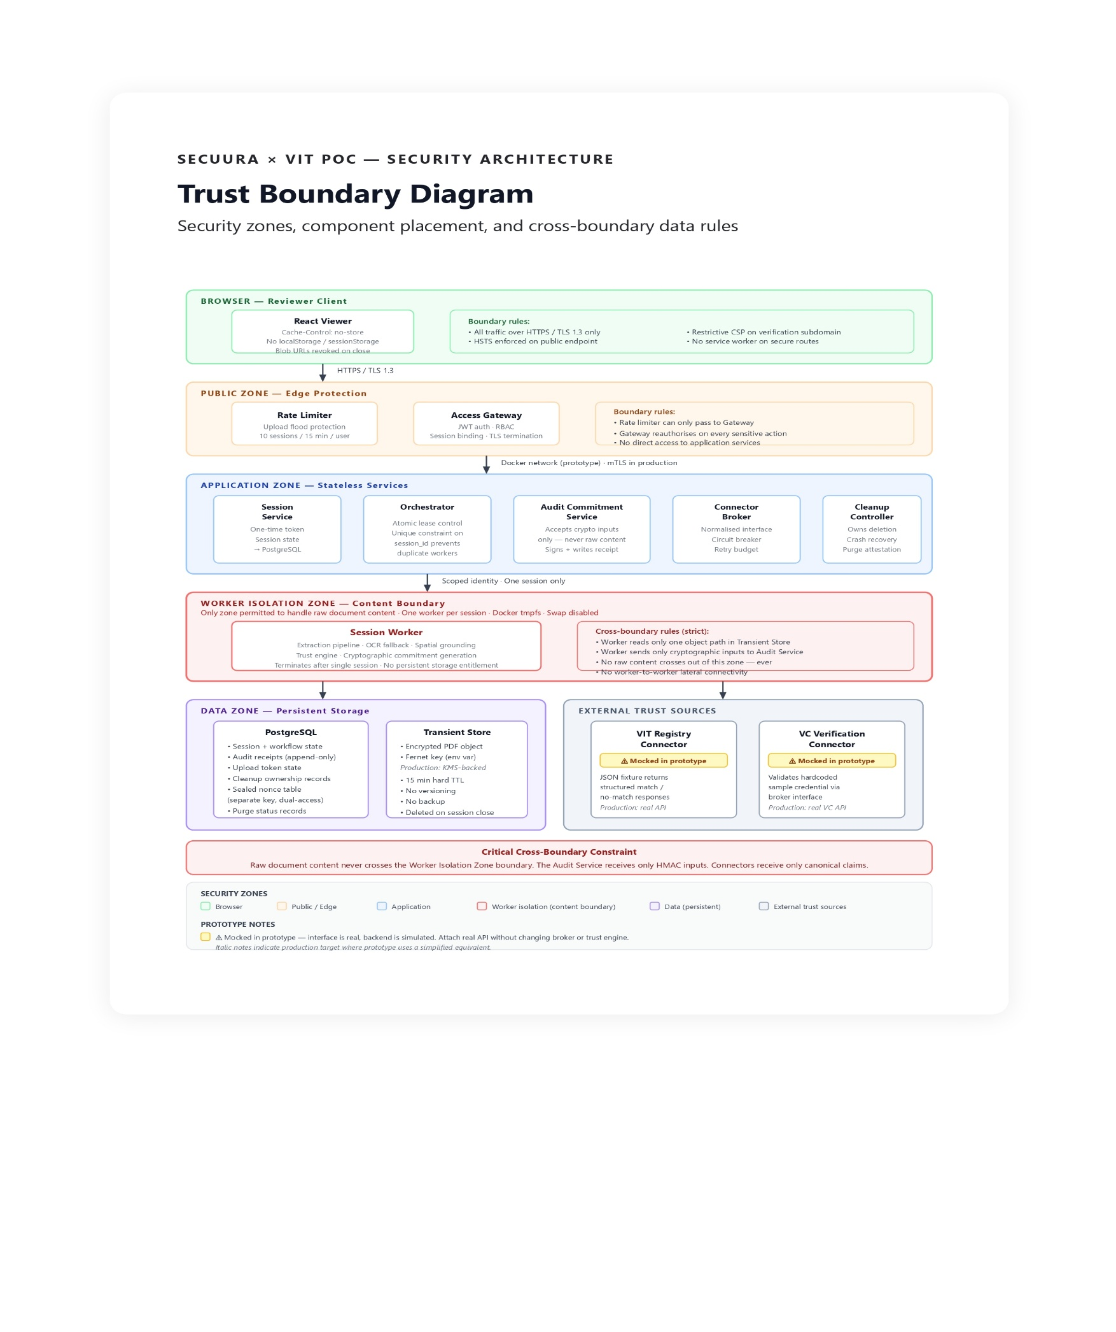Figure 2. Trust Boundary Diagram security zones, component placement, and cross-boundary data rules

17.1 Identity and Access Management
Human access uses JWT-based login with username and password, session renewal on privilege change, and short session TTLs.

RBAC permissions matrix
Role | Create session | Upload file | Open verification session | View live evidence | View audit receipts | Break-glass nonce access | Manage connectors | Manage infrastructure
Uploader | Yes | Yes | No | No | No | No | No | No
Reviewer | Yes | Yes | Yes | Yes | Limited to own authorized cases | No | No | No
Security Administrator | No | No | No | No | Yes | Logical dual-access workflow only | No | No
Platform Operator | No | No | No | No | No content access | No | No | Yes
Connector Administrator | No | No | No | No | No | No | Yes | Limited

Separation of duty
- Reviewers cannot access sealed nonce data.
- Platform operators cannot read document content or audit mappings.
- Security administrators can inspect receipts but need a logical dual-access workflow for recovery-table access.
- Connector administrators cannot approve their own recovery-table access requests.

17.2 Upload and abuse protection
- 10 session-creation attempts per user per 15 minutes
- 3 concurrent uploads per user
- 25 MB file cap
- 200-page cap
- application-layer rate limiting for upload flooding and malformed requests
- signed one-time upload token
- replay protection via one-use token state
- partial-upload cleanup
- hard parser and OCR timeouts
- AV scan and PDF policy validation

17.3 One-time upload token lifecycle
- token lifetime: 10 minutes from issue
- token is bound to session ID, uploader identity, content type, and maximum size
- token becomes invalid after first successful object create
- if upload starts before expiry, a 5-minute completion grace period is allowed
- if the upload fails or is abandoned, partial object is deleted and token is revoked
- replay attempts return 409 token-used or 401 token-expired

17.4 Encryption in transit and at rest
Controls:
- TLS 1.3 preferred, TLS 1.2 only where necessary
- HSTS on public endpoints
- localhost or Docker network communication
- Python cryptography library using Fernet with the key stored in an environment variable
- separate keys for storage, commitments, and signing

17.5 Memory-only processing guarantees
The architecture removes vague "best-effort tmpfs" language. The baseline worker runtime requires:
- Docker Compose services on a single machine or small VM
- swap disabled at the host level
- Docker tmpfs mount or equivalent RAM-only volume
- read-only root filesystem where supported
- no privilege escalation
- dropped Linux capabilities
- seccomp and AppArmor/SELinux enforcement where supported by the host
- no hostPath-style mounts
- worker termination after every session
If the deployment target cannot guarantee swap-disabled memory-only execution, the fallback is an encrypted ephemeral disk with session key destruction. That configuration is treated as a different assurance level and documented accordingly.

17.6 Log redaction and privacy controls
The POC therefore logs:
- event type
- pseudonymous session reference
- pseudonymous reviewer reference
- connector ID
- outcome
- reason code
- latency
- purge result
The POC does not log:
- raw PDF bytes
- OCR output
- extracted claims

- names or IDs from documents
- raw session IDs
- access tokens
- connector raw payloads
- sealed nonce contents

17.7 Browser-side defences
The POC therefore applies all of the following:
- Cache-Control: no-cache, no-store, must-revalidate
- Pragma: no-cache
- Expires: 0
- no service worker on secure verification routes
- no use of localStorage, sessionStorage, IndexedDB, Cache, or CacheStorage for document content
- blob URL revocation on viewer close
- in-memory state clear on route exit
- dedicated secure subdomain with restrictive CSP
- optional VDI/browser-isolation mode for high-risk environments

17.8 Security testing strategy
The POC includes:
- SAST on every merge
- dependency and container scanning
- infrastructure-as-code scanning
- secret scanning
- DAST for public endpoints
- PDF parser fuzz testing
- negative tests for malformed PDFs
- chaos tests for worker crash and cleanup recovery
- manual penetration test recommended before any production pilot (out of scope for prototype phase)
- audit-log tamper test
- break-glass workflow test

18. Threat Model (STRIDE Summary)

Spoofing
Threats:
- stolen reviewer session
- forged service identity
- forged connector endpoint
Mitigations:
- JWT-based login with username and password
- short-lived session cookies
- localhost or Docker network communication
- connector certificate pinning or signed auth
- session anomaly detection

Tampering
Threats:
- PDF altered in transit
- audit record modification
- connector response manipulation
Mitigations:
- TLS
- signed receipts
- append-only audit model
- receipt-hash anchoring
- log integrity checks

Repudiation
Threats:
- reviewer denies an action
- operator deletes or modifies evidence
Mitigations:
- signed audit receipt
- receipt-hash integrity
- immutable audit trail
- privileged access logging
- logical dual-access workflow for recovery-table access

Information disclosure
Threats:
- leaked logs
- browser caching
- worker swap or disk leakage
- connector oversharing

- external provider retention
Mitigations:
- content-minimised logging
- no-store headers plus client-side restrictions
- swap-disabled worker host
- local OCR baseline
- egress allow-list
- DPA and provider-gate controls for any future external provider

Denial of service
Threats:
- upload flooding
- oversized files
- connector exhaustion
- orchestrator or PostgreSQL outage
Mitigations:
- rate limits
- file caps
- queue back-pressure
- retry budgets
- circuit breakers
- cleanup independent of service restarts

Elevation of privilege
Threats:
- reviewer gains admin access
- operator gains document access
- app service reads recovery-vault data
Mitigations:
- least privilege
- separate admin and data planes
- SoD
- break-glass approval workflow
- workload-scoped IAM

19. Network Architecture
The network architecture described in this section represents the production target topology. In the prototype, network segmentation is enforced via Docker Compose network isolation with service-level allow rules and deny-all defaults. Workers cannot reach other workers, and data containers are accessible only to authorised application services within the Compose network. The subnet and VPC topology below is retained as the production deployment reference.

VPC / VNet topology
Public subnet tier: WAF, load balancer, API gateway only
Application private subnets: gateway service, session service, orchestrator, connector broker, audit commitment service
Worker isolated subnets: session-scoped workers only; no inbound from internet
Data private subnets: PostgreSQL, recovery-table endpoints
Egress subnet / NAT: controlled outbound path with FQDN allow-list

Security group model
- WAF/LB can reach gateway only
- gateway can reach app services only on required ports
- app services can reach workflow store, audit store, and secrets only
- workers can reach transient object store, connector broker, allowed connectors, encryption-key source, and audit commitment service
- no lateral worker-to-worker connectivity
- data subnets deny east-west access except explicit allow rules

East-west controls
- localhost or Docker network communication
- namespace or subnet segmentation
- network policies blocking lateral movement
- deny-all default
- service-to-service auth with workload identity

Egress filtering
Workers can call only:
- VIT registry endpoint
- approved VC issuer / status endpoints
- encryption-key source
- audit store endpoint
- logging sink
All other egress is denied.

20. Cloud Deployment Model
The reference deployment is cloud-preferred and vendor-neutral in pattern.

Reference stack
- WAF + API gateway
- JWT-based login with username and password
- stateless Python services using FastAPI
- Docker Compose on a single machine or small VM
- encrypted object storage for transient PDFs using Python cryptography library with Fernet and a key stored in an environment variable
- single PostgreSQL container in Docker serving workflow and audit metadata
- PostgreSQL as the sole session state store
- environment variables for secrets during the prototype; documented separation for local development
- centralized logging

PostgreSQL session-state design
The prototype does not use Redis. PostgreSQL is the sole session state store for leases, upload-token state, cleanup ownership, and audit persistence. This keeps the prototype deployable on a single machine while preserving the same session-state model used by the architecture.

21. Compliance and Regulatory Considerations

GDPR
GDPR governs personal-data processing and requires lawful processing, minimisation, storage limitation, security, and accountability. For EU recruitment workflows, the controller must document the lawful basis before go-live, typically Article 6(1)(b) for steps prior to entering a contract or Article 6(1)(f) with a balancing assessment where legitimate interests are used. Data subject rights such as access and erasure must be operationalized for retained metadata. Processor arrangements with external vendors require contractual controls under Article 28.

Recruitment data processing
The system minimizes retained data, avoids storing candidate documents after verification, and stores only the metadata required for auditability and controlled investigations. Any use beyond recruitment verification requires a separate purpose assessment.

Academic transcript verification
Where the system operates for an educational institution or handles maintained education records on its behalf, FERPA considerations apply and agreements must preserve student-record confidentiality and controlled disclosure.

External providers
No external OCR or extraction provider is enabled in baseline. If enabled later, the controller must execute a DPA, assess region and transfer implications, and document retention and deletion terms.

Standards mapping
ISO/IEC 27001: overall ISMS, risk management, access control, logging, supplier management, and incident handling alignment.
SOC 2 Trust Services Criteria: security, availability, processing integrity, confidentiality, and privacy control objectives for the persistent and operational components.
eIDAS: the POC is not a qualified trust service, but receipt integrity and auditability are structured to support trust-service-style evidence handling if extended later. eIDAS requires periodic audits for qualified trust services, reinforcing the need for tamper-evident evidence and controlled audit trails.

22. Non-Functional Requirements

Availability
POC target:
- availability is not formally committed in the prototype phase; the production target is 99.0% monthly for session creation, upload, and the verification control plane during defined business windows
- optional Cardano anchoring excluded from core availability target

Performance
- 95% of text PDFs up to 10 pages processed in under 120 seconds
- 99% of uploads under 25 MB accepted or rejected within 30 seconds

- cleanup confirmation within 60 seconds of session end for normal flows

Security
- no raw content in persistent application logs
- all privileged actions logged
- all public endpoints protected by application-layer rate limiting and input validation
- all service traffic encrypted
- all sensitive secrets separated from source code

Privacy
- no persistent raw documents
- no persistent extracted claims
- no persistent stable document identifiers
- metadata retained only per approved schedule

23. Infrastructure Reliability and Disaster Recovery

Audit store
The audit store is the persistent system of record and therefore requires reliability controls. In the prototype, it runs as a single PostgreSQL container in Docker with scheduled logical backups and restore testing.
Controls:
- encrypted volume for PostgreSQL data
- scheduled pg_dump backups
- periodic restore test on a separate local or VM instance
- append-only application logic
- restricted admin access
- audit-log access monitoring

Workflow store
The workflow store uses the same single PostgreSQL container in Docker as the audit store, with separate schemas for workflow and audit state. This store governs cleanup ownership and session truth.

Cleanup responsibility
Cleanup ownership is independent of the orchestrator process. If the orchestrator fails:
- object TTL remains active
- cleanup controller scans for stale leases
- stale sessions are marked abandoned
- transient object is deleted
- sealed nonce blob is destroyed if no receipt exists
- purge status is recorded

Worker crash recovery
Workers write heartbeats every 15 seconds. If heartbeat age exceeds 60 seconds:
- active lease is marked stale
- no second worker can start until cleanup finishes
- cleanup controller takes ownership
- session transitions to FAILED_PURGED or FAILED_RETRIABLE
- retry requires a new verification session unless policy explicitly allows re-open before purge

24. Production Scaling Roadmap
The following table documents the prototype implementation choice for each infrastructure component alongside the production-grade equivalent. This is provided as a reference for Secuura AI's engineering team to understand the scaling path from POC to production.
Component | Prototype Implementation | Production Target
Authentication | JWT-based login with username and password | Enterprise SSO with OIDC or SAML federation and MFA
Service communication | Localhost or Docker network | mTLS between all services
Encryption key management | Fernet symmetric key in environment variable | KMS-backed key management with separate keys per purpose
Worker orchestration | Docker Compose one-shot service on single VM | Kubernetes Jobs on isolated swap-disabled node pools
Primary data store | Single PostgreSQL container | Multi-AZ PostgreSQL with point-in-time recovery
Session state and coordination | PostgreSQL sole state store | PostgreSQL with Redis HA for non-durable coordination
Recovery vault | Second encrypted PostgreSQL table with separate key and logical dual-access | HSM-backed vault with hardware dual-control
Network segmentation | Docker Compose network isolation with deny-all defaults | Full VPC topology with subnet tiers, security groups, and east-west mTLS
Edge protection | Application-layer rate limiting and input validation | WAF with managed rule sets at the network edge
Blockchain anchoring | Hash display only — hash that would be submitted is shown | Live Cardano testnet or mainnet anchoring

